***Final Project for Mobile Apps***

**Contributors:**

Tswjfwmeng Vang

**Technologies Used & References:**

FusedLocationProviderClient -- location services

[https://developers.google.com/android/reference/com/google/android/gms/location/Fuse`dLocationProviderClient](https://developers.google.com/android/reference/com/google/android/gms/location/FusedLocationProviderClient)

Geocoder -- location details

<https://developer.android.com/reference/android/location/Geocoder>

“Get the last known location”

<https://developer.android.com/training/location/retrieve-current>

**Prerequisites:**

Users MUST allow GPS location tracking otherwise this app will not work correctly. The app should ask its users for permission at the beginning of the app. If it doesn’t ask for permission, the user may already have had the permissions accepted.

Google Play also must be updated to the most recent one available in the emulator/device. This is required due to the use of the FusedLocationProviderClient API. If you’re already opening the project from the .zip file I provided, this may already be done. Otherwise:

1. Go to to the Tools > SDK Manager, found at the top of the Android Studios screen
2. A window should open. On the left, go to the System Settings > Android SDK tab
3. In the middle of the window, click on the SDK Tools tab.
4. Find and enable Google Play services. Click “Apply”.

Check out this link to learn more about updating Google Play. <https://developer.android.com/studio/intro/update>

Lastly, you may have to sign in with an actual Gmail account in order to update Google Play on the device you are running the app.

**Troubleshooting:**

If your location (address) is showing up as null, “NULL”, or “FAILED”, then follow these steps:

1. Go into your emulator’s settings then, click on “Location” tab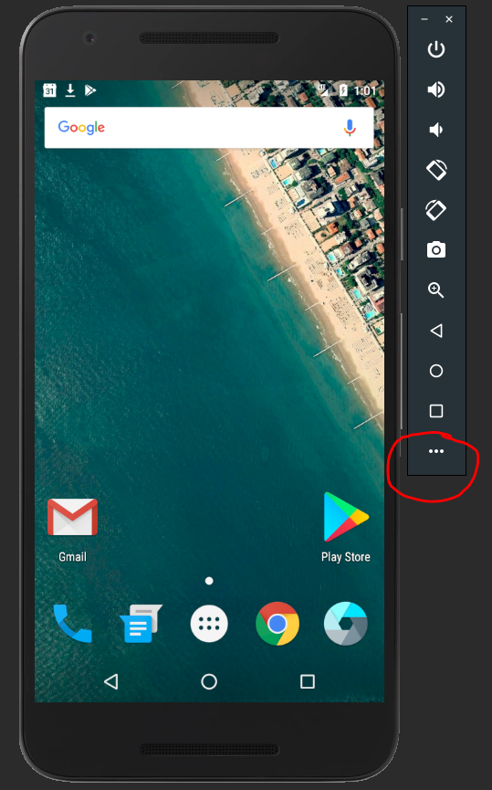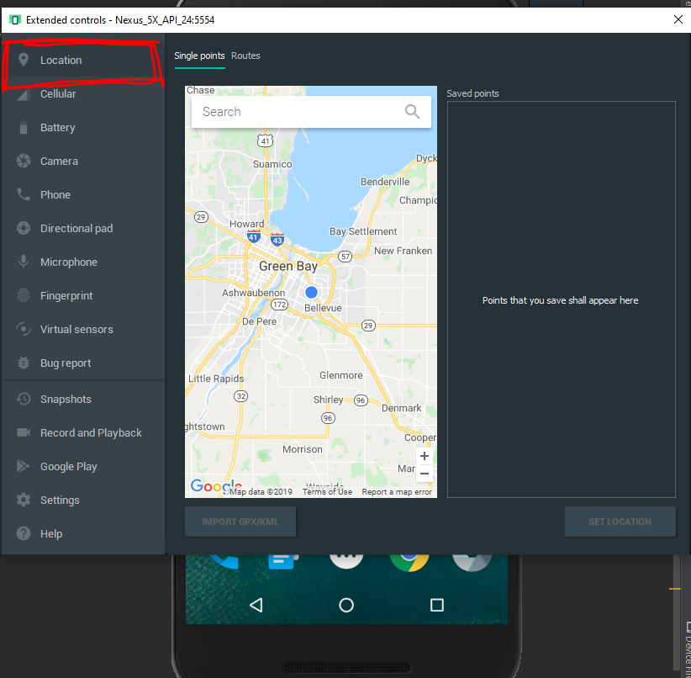
2. Choose a destination on the map, preferably a place where an address is valid and simple.
   1. Ex. a Walmart, a school, your current house, your neighbor’s house, etc.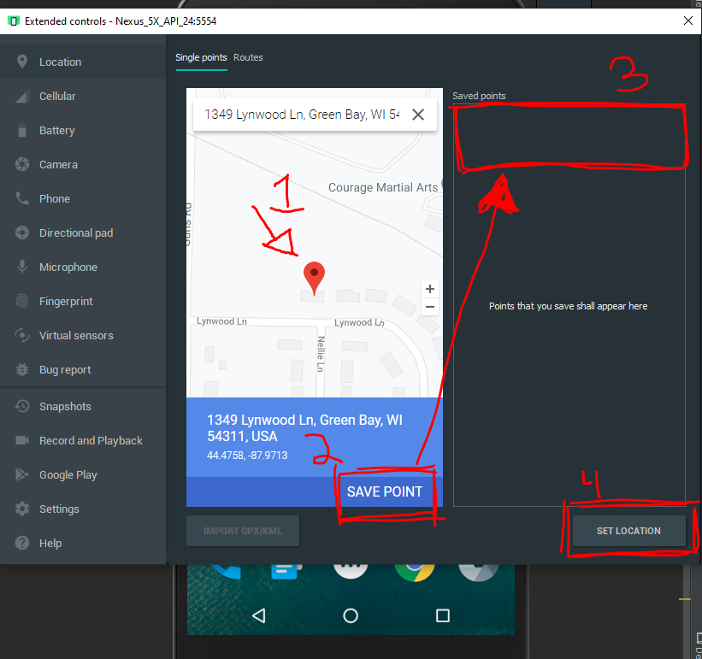

(fig. 1.0, The numbers on the photo do NOT represent the Troubleshooting tutorial bullet points. These numbers are general steps to set your location)

1. At the bottom right, click on “Set Location”. Your “Saved Points” list should be populated to that specific location that you just recently clicked on. It may give it a unique name for purposes that is irrelevant to us at the moment.
2. Lastly, the app and emulator most likely uses the most recent location that you saved in your “Saved Points” list (so the top of the list) to run in the app. If you need to, delete all of them except for 1 to make sure the app is pulling the correct location.

**Writeup:**

I wanted to do something with location services. I found the FusedLocationProviderClient API on Android’s documentation page and thought that it would be the best way to go about implementing location services. Fortunately, from what I’ve read, using the FusedLocationProviderClient API is the most updated location services Android is supporting, which made it more reliable for me to use.

The app is pretty basic. All the user is able to do is type in an informal name for the place the user is currently at, like “Grandma’s House”. The app will then get the longitude and latitude coordinates of its user, then plug those coordinates into Geocoder to obtain specific details such as the address.

From there, the user will add it to a pre-existing list of places they’ve visited (they’re just hardcoded just for the sake of an example). The last activity will allow the user to delete an item within the list if they wish to do so. All they would have to do is type in the index number (which is listed on the side of the items) and press delete. The delete button will then refresh the last activity with the updated version of the list.